**DEPLOY A MULTI-TIER WEB APPLICATION ON KUBERNETES**

The File Structure

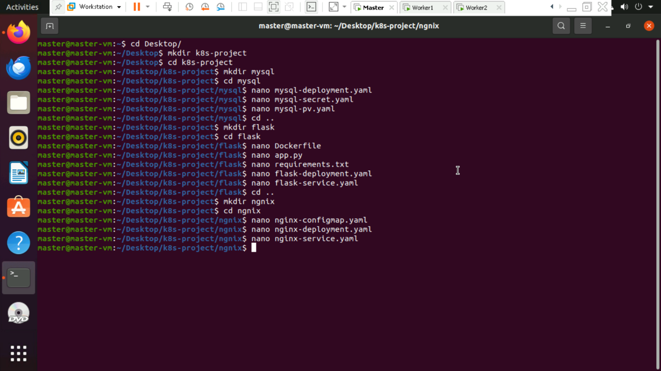

**Persistent Volume (`mysql-pv.yaml`) file**

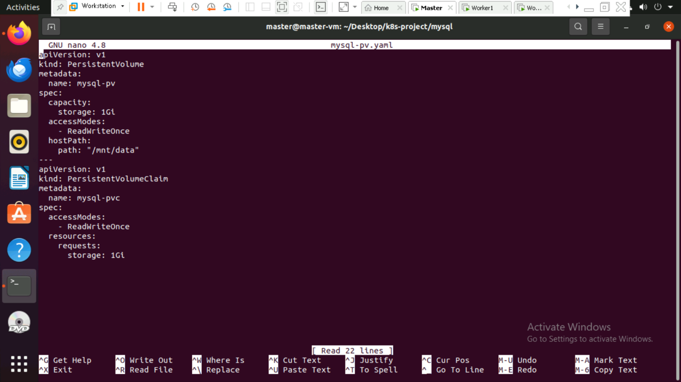

**StatefulSet (`mysql-deployment.yaml`) file**

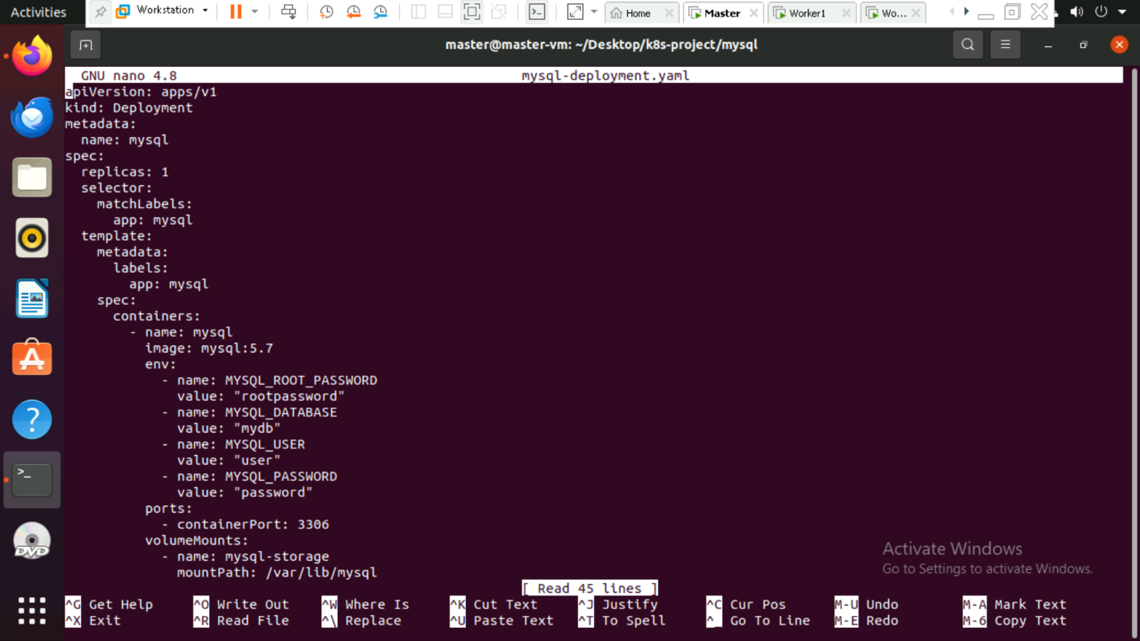

**Secret (`mysql-secret.yaml`) file**

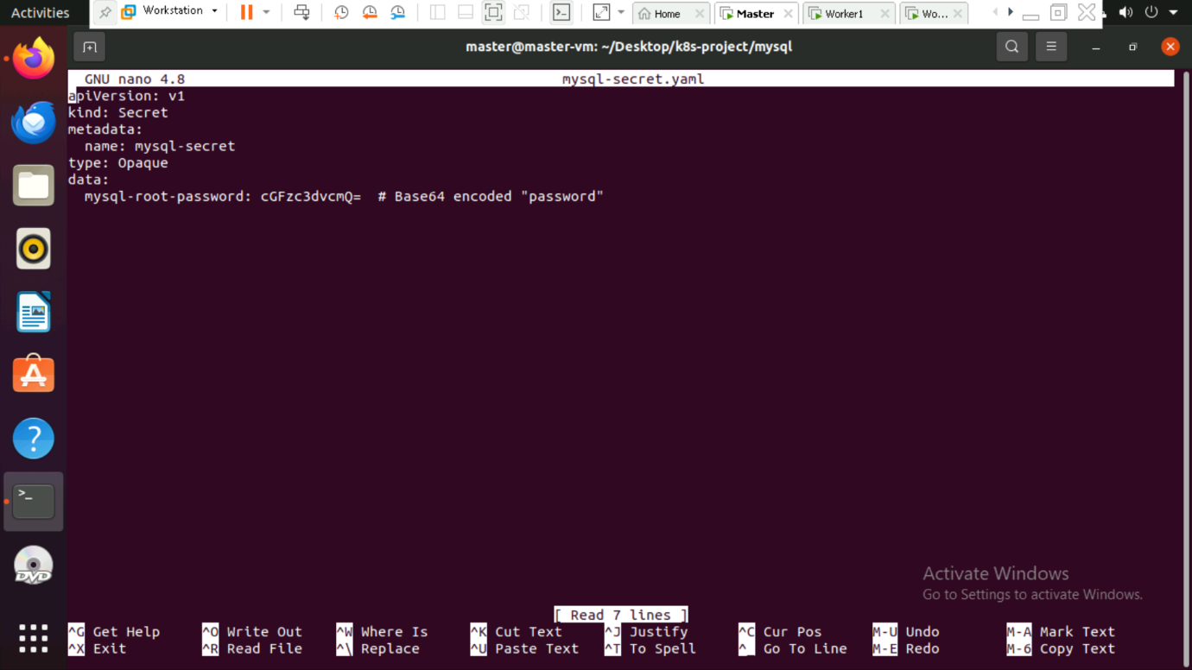

**Flask app.py file**

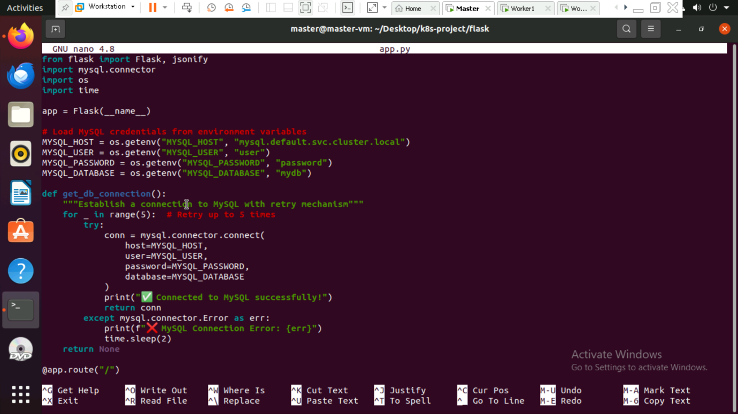

**Flask- Dcokerfile**

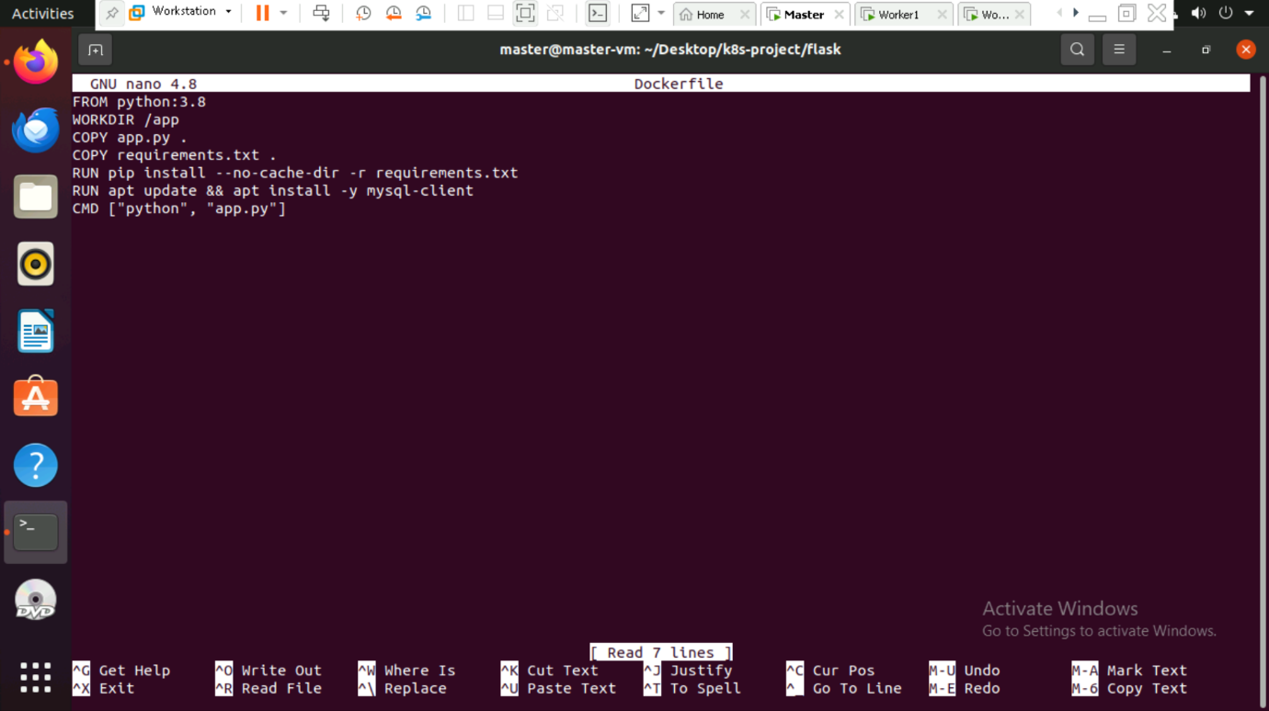

**Flask- Requirements.txt file**

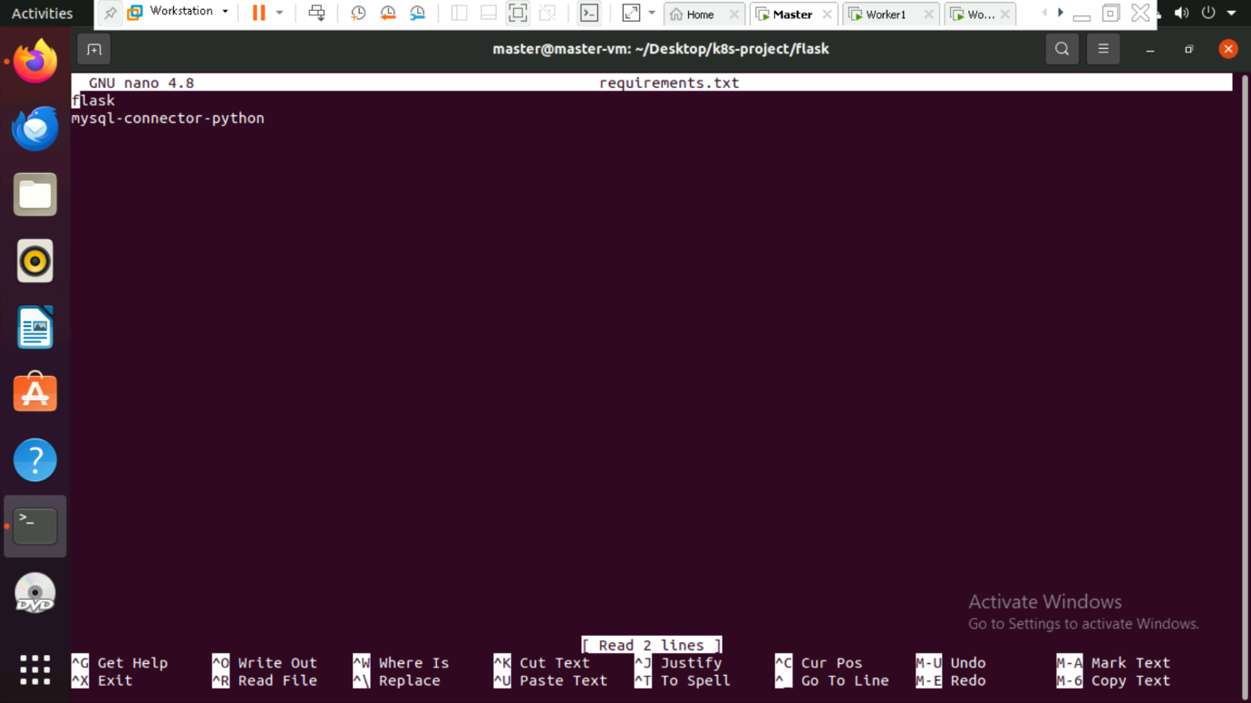

**Service (`flask-service.yaml` )**

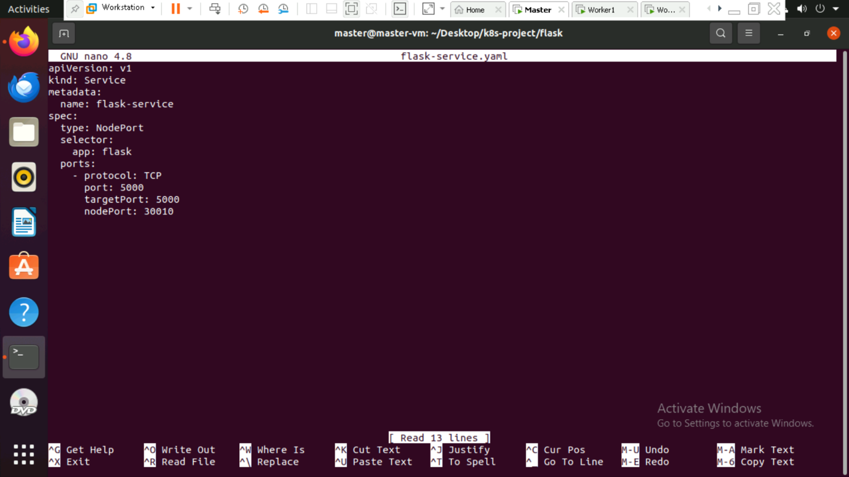

**Deployment (`flask-deployment.yaml`)**

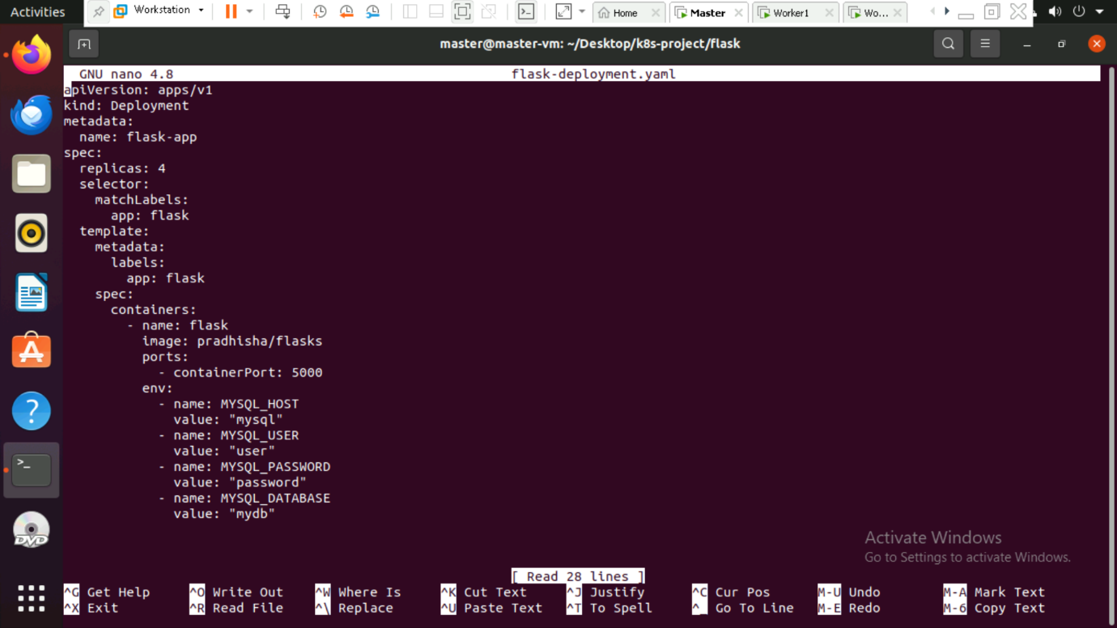

**ConfigMap (`nginx-configmap.yaml`) file**

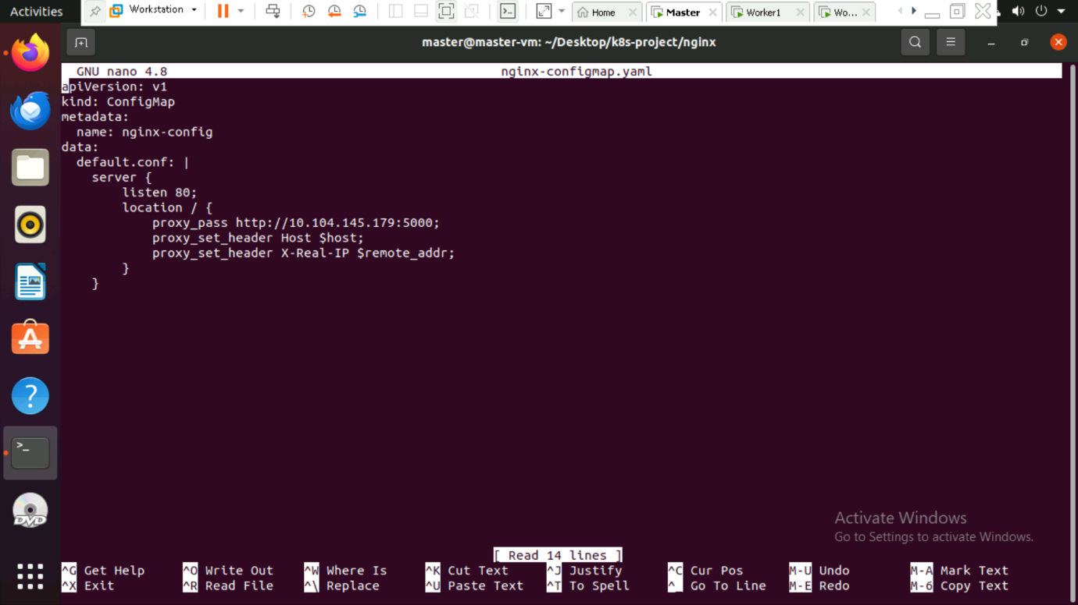

**Deployment (`nginx-deployment.yaml`) file**

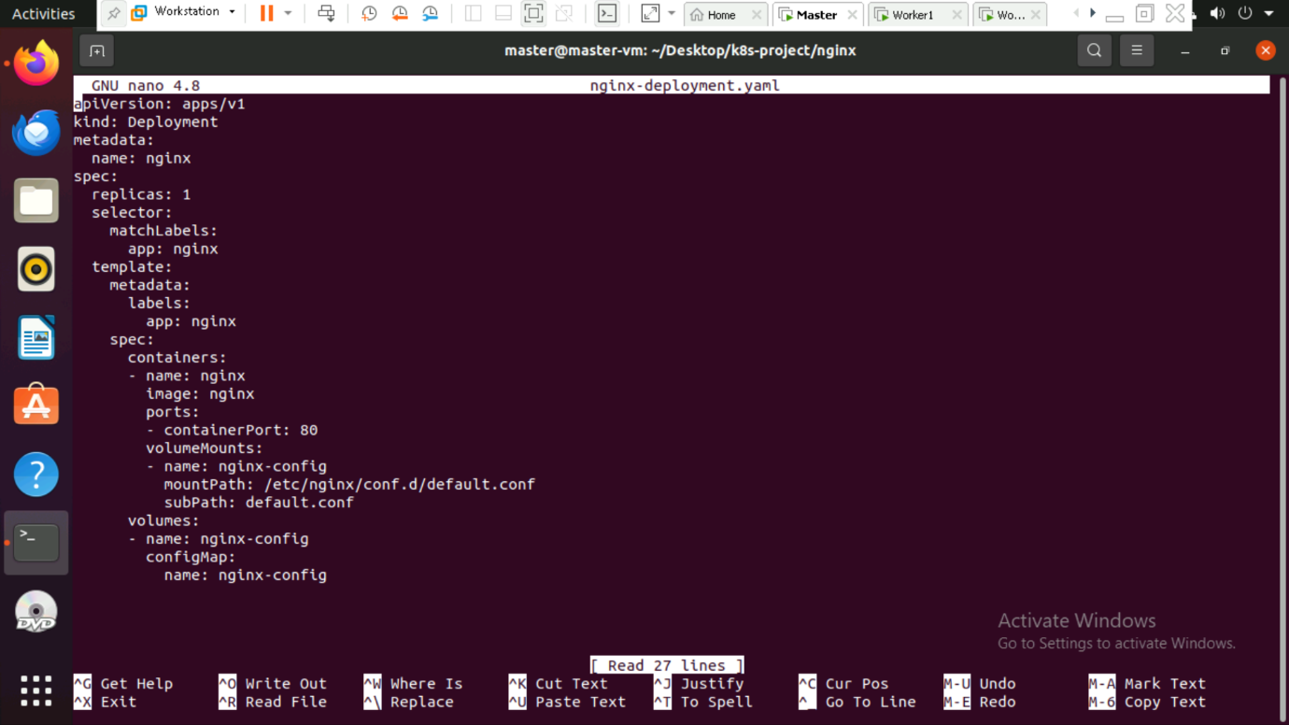

**Service (`nginx-service.yaml`) file**

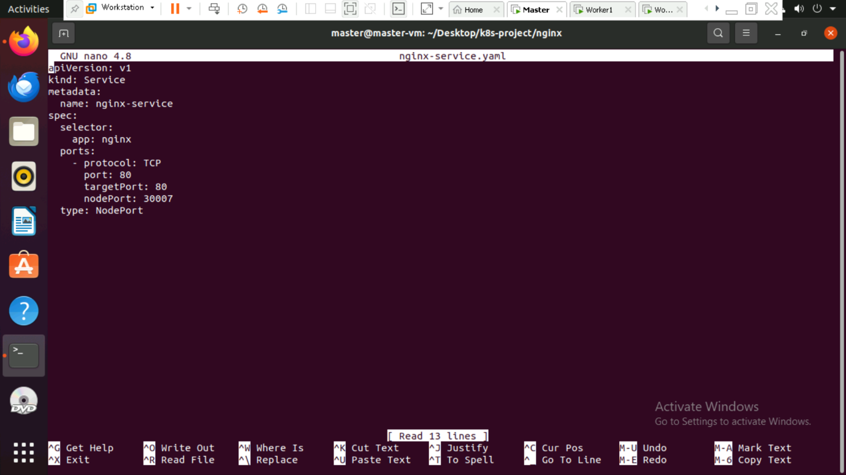

**1. Build and Push Docker Image**

1. Navigate to the Flask application directory:
   * cd flask

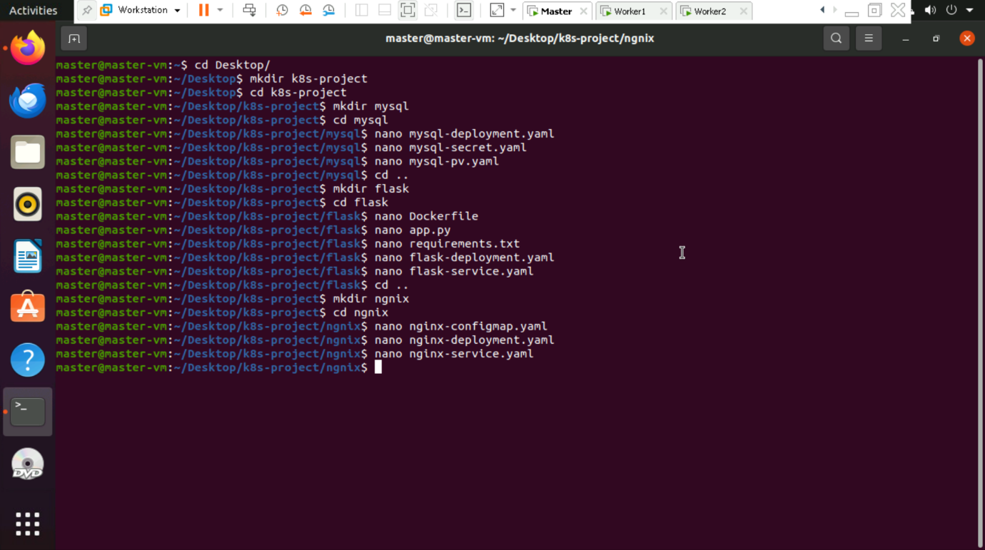

1. Build the Docker image:
   * docker build -t dockerhub_username/flaskapp .

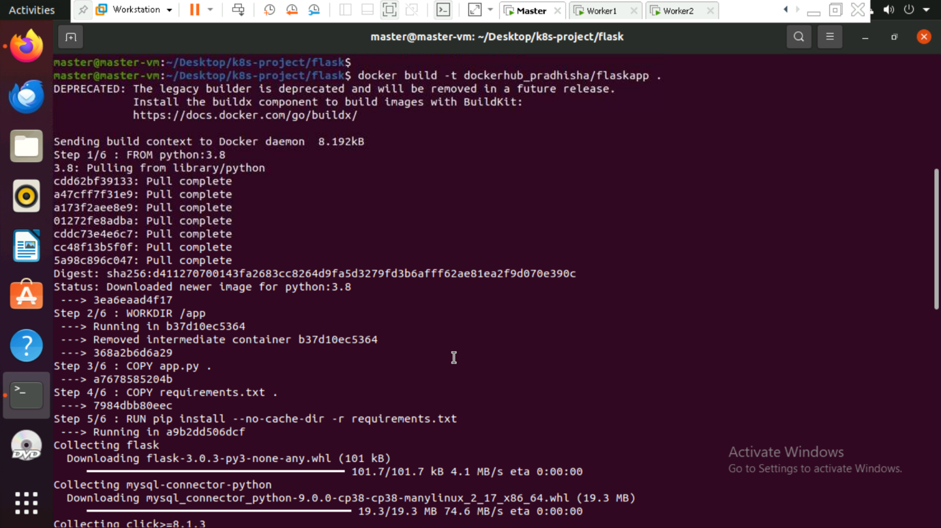

1. Push the image to Docker Hub:
   * docker push dockerhub_username/flaskapp

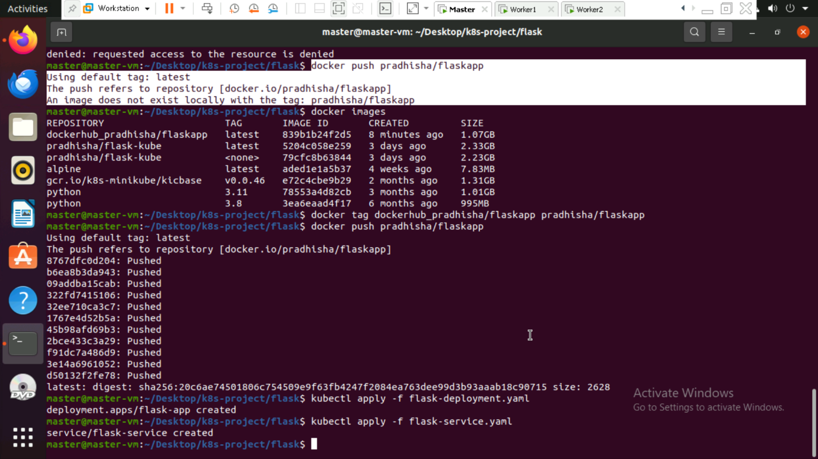

**2. Deploy the Flask Application**

1. Apply the Flask Deployment manifest:
   * kubectl apply -f flask-deployment.yaml



1. Apply the Flask Service manifest:
   * kubectl apply -f flask-service.yaml

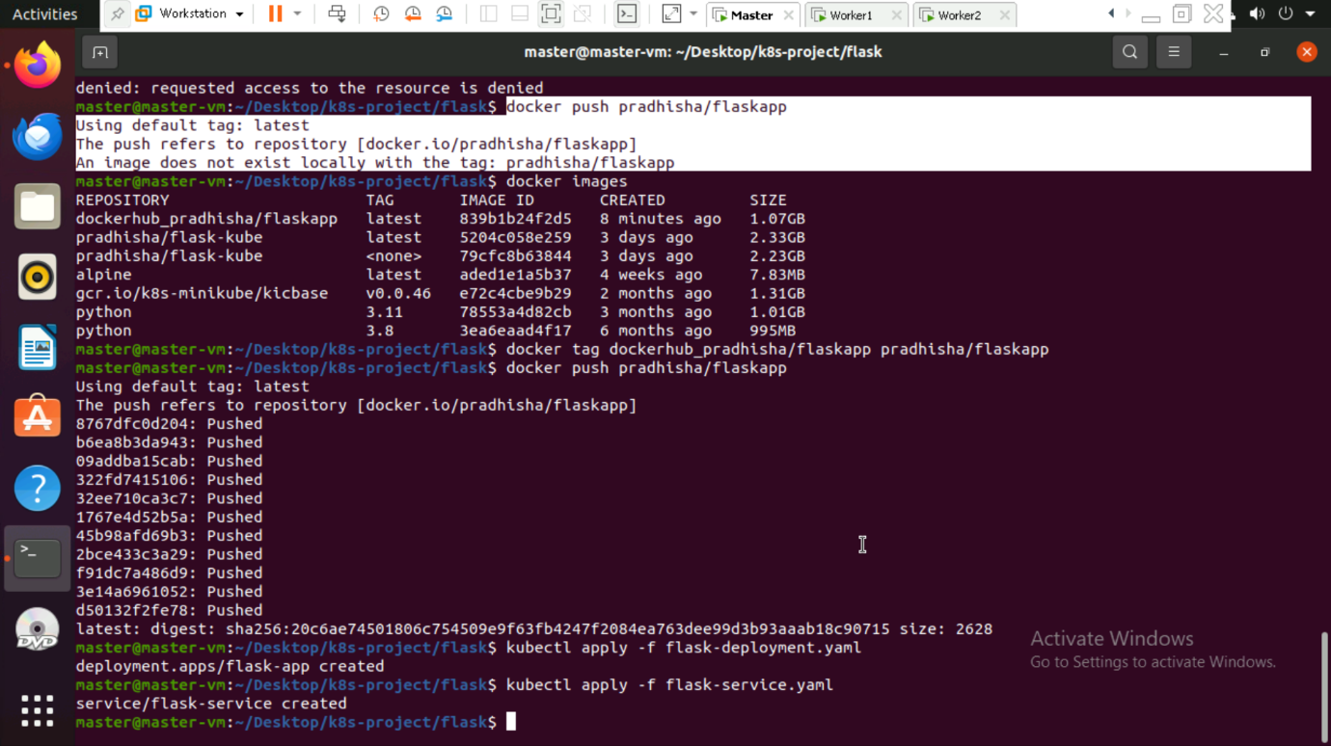

**3. Deploy the MySQL Database**

1. Navigate to the MySQL directory:
   * cd .. && cd mysql
2. Apply the MySQL Deployment manifest:
   * kubectl apply -f mysql-deployment.yaml

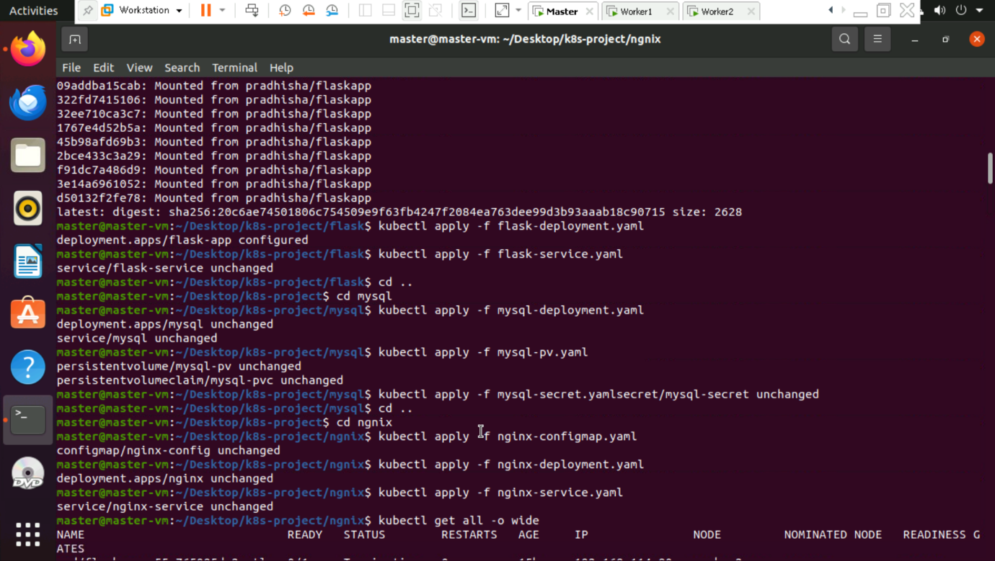

1. Apply the MySQL Persistent Volume manifest:
   * kubectl apply -f mysql-pv.yaml

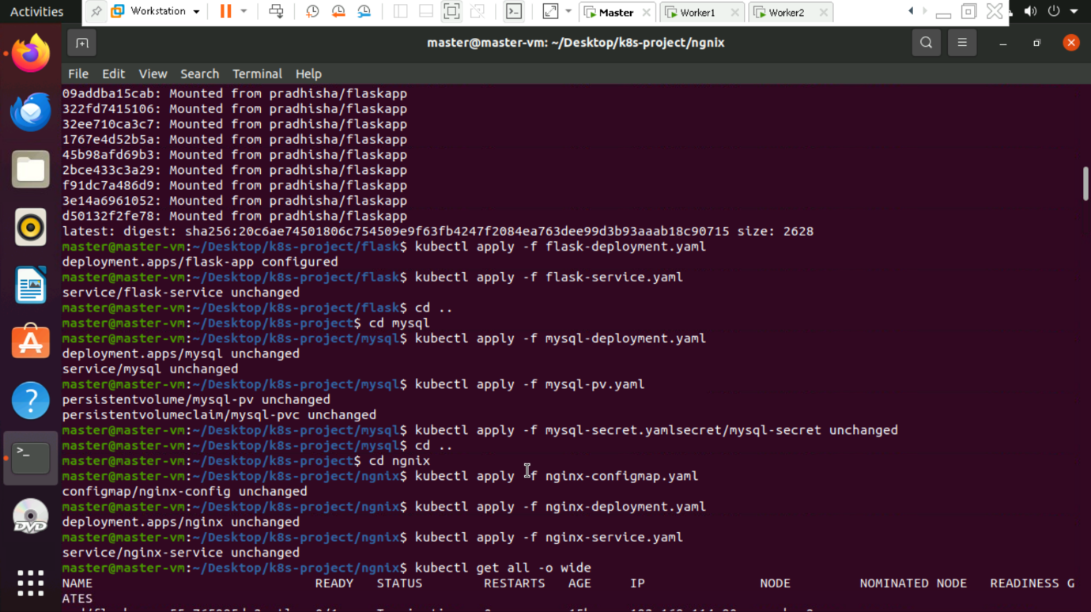

1. Apply the MySQL Secret manifest:
   * kubectl apply -f mysql-secret.yaml



**4. Deploy the Nginx Service**

1. Navigate to the Nginx directory:
   * cd .. && cd nginx
2. Apply the Nginx ConfigMap manifest:
   * kubectl apply -f nginx-configmap.yaml



1. Apply the Nginx Deployment manifest:
   * kubectl apply -f nginx-deployment.yaml

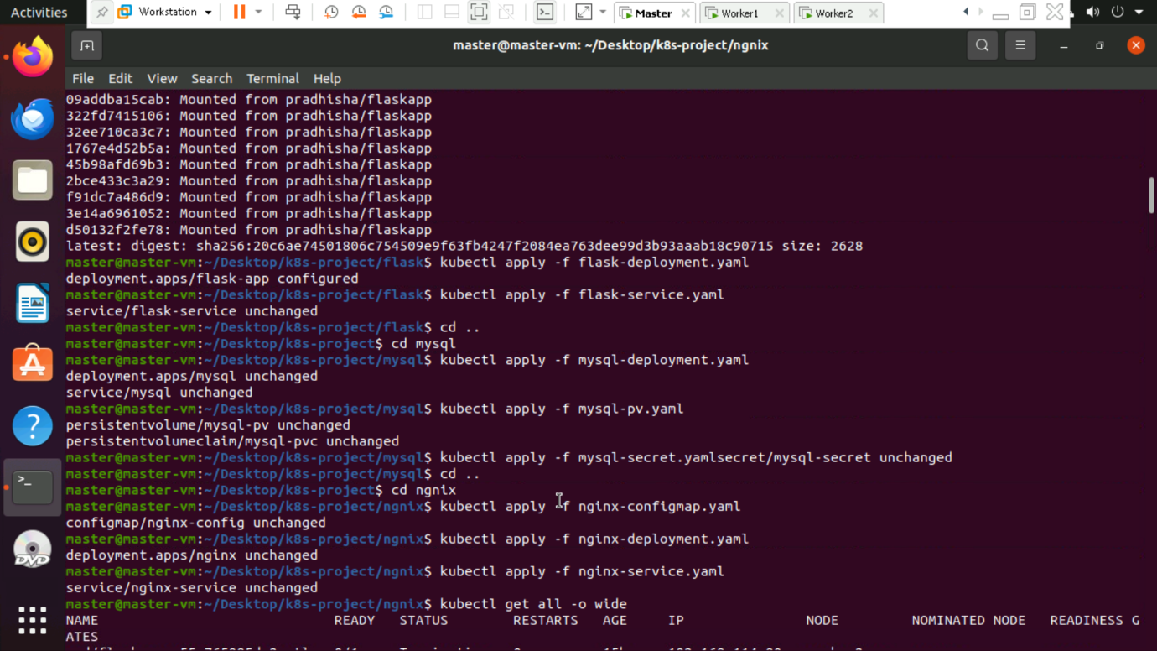

1. Apply the Nginx Service manifest:
   * kubectl apply -f nginx-service.yaml



**5. Verify the Deployment**

1. Check the status of all Kubernetes resources:
   * kubectl get all -o wide

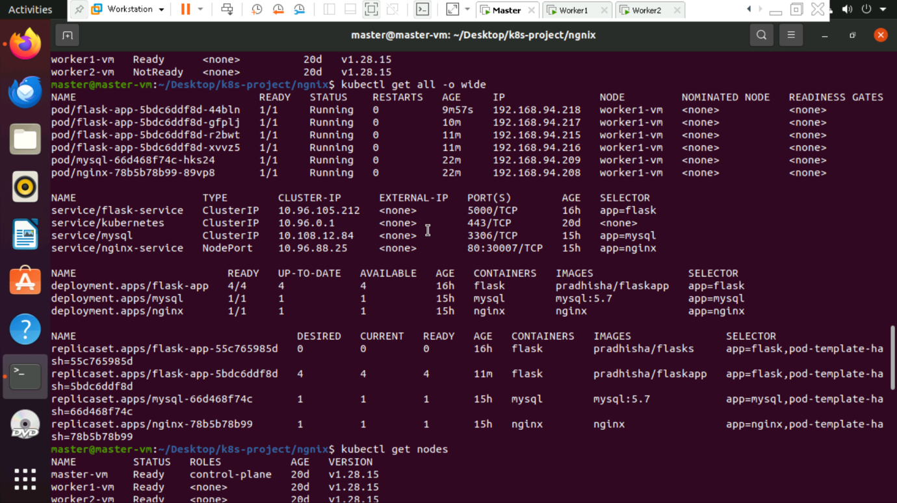

**6. Access the Application**

1. Retrieve the worker node IP:
   * kubectl get nodes -o wide

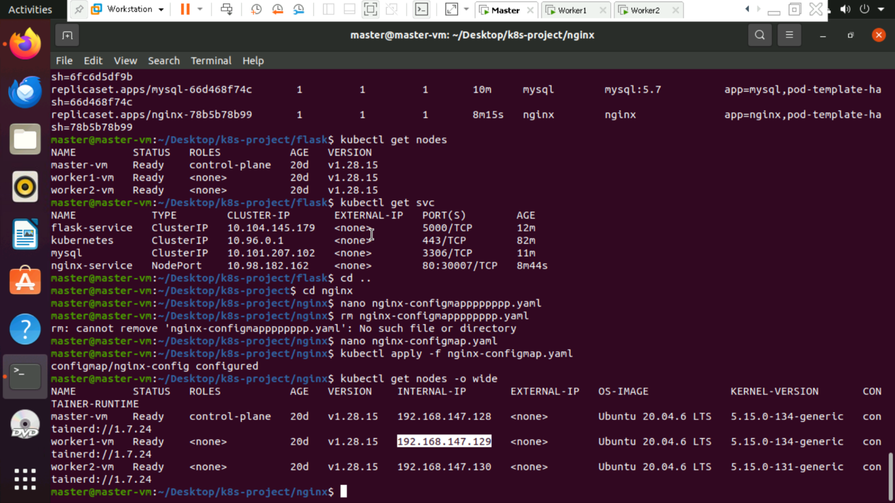

1. Access the application in the browser:

<http://192.168.147.129:30010/>

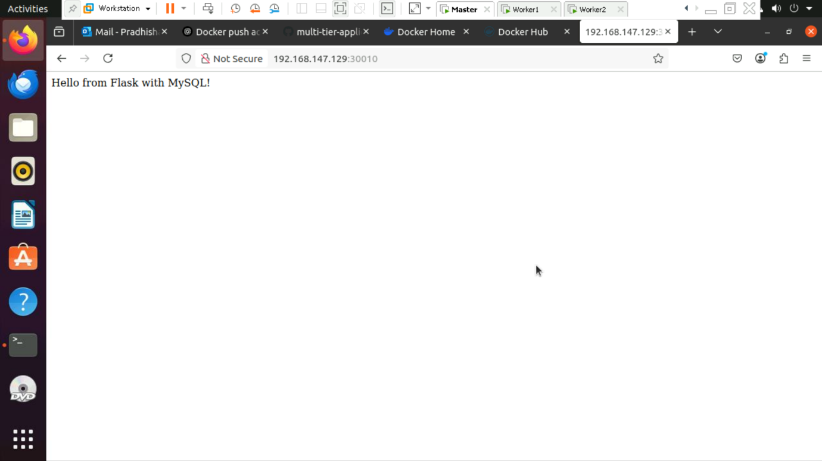

**7. Configure MySQL Database**

1. Access the MySQL pod:

kubectl exec -it mysql-0 -- mysql -u root -p

1. Create and configure the database:

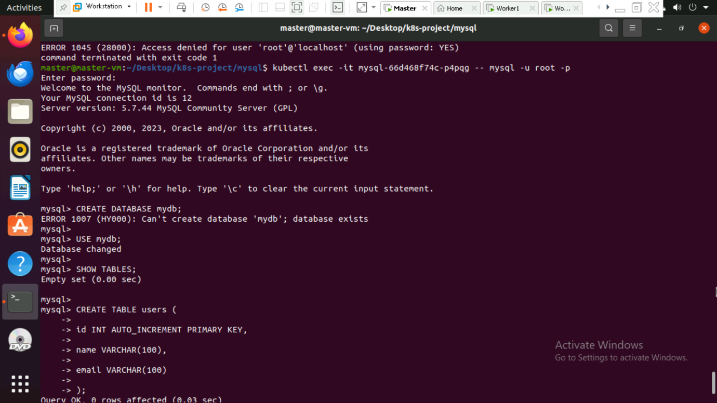

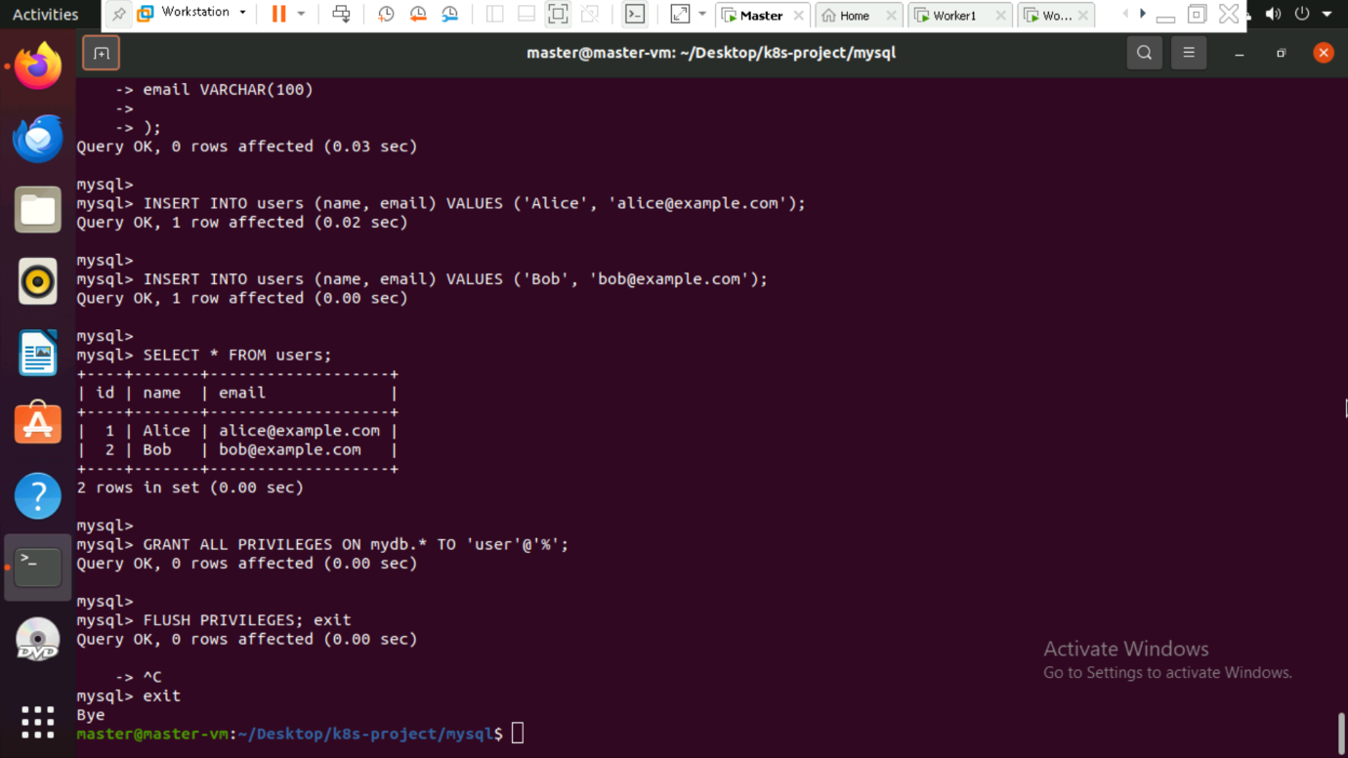

1. Access the users API endpoint:

<http://192.168.147.129:30010/users>

